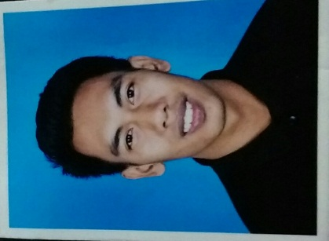

|  |
| --- |
| **Personal Information** |

Name : Muhammad Fathul Hazim Bin Zuber

Permanent Address : 275 Lrg Semarak 1/3G Taman Semarak,

08000 Sungai Petani,

Kedah

Course : Bachelor of Engineering (Hons) Technology in Electrical.

Internship Date : 31st July 2017 – 1st December 2017 (18 Weeks) .

Email : hazimzuber21@gmail.com

Tel Number : +6019 4712649 (Mobile)

|  |
| --- |
| **Personal Particulars & Preferences** |

Date of Birth : 29 May 1994

Nationality : Malaysia

Religion : Islam

Gender : Male

Marital Status : Single

|  |
| --- |
| **Additional Info** |

**CAREER OBJECTIVE:**

To gain further exposure and experience in Electrical Engineering.

To secure a challenging position where I can effectively contribute my skills.

**STRENGTHS:**

Self-motivated, aggressive, matured personality, dynamic team player and able to work independently. Basic knowledge in improvement project to solve electrical issues.

Hardworking, dedicated and persevering.

Sense of responsible.

Initiative to learn, accept new challenges and possess leadership qualities.

|  |
| --- |
| **Educational Background** |

UniKL British Malaysian Institute (UniKL BMI), Selangor

* Bachelor of Engineering Technology in Electrical
* Currently Year 4, Semester 7 (2014-2018)
* Current CGPA 2.96

Universiti Tenaga Nasional

* Foundation in Electrical Power Engineering (UNITEN)
* Graduated on May 2012
* CGPA: 2.45

Maktab Rendah Sains Kubang Pasu

* Sijil Pelajaran Malaysia (SPM) 2011
* 5A, 3B, 1C

|  |
| --- |
| **Curricular Activities** |

# Participate in Community Service Club BMI.

# Participate in Kadet Remaja Sekolah Marching Competition.

|  |
| --- |
| **Skills And Abilities** |

# Language Spoken Written

English Fair Fair

Malay Good Good

Computer Programs: 

* Experience in using Microsoft office (Microsoft word, Microsoft power point, Microsoft excels)
* Experience in using MATLAB, C++ programming software
* Experience in using PLC programmable logic controller programming
* Experience in using Fuzzy Tech Software
* Experience In Using Proteus Software
* Experience In Using Matlab

|  |
| --- |
| **Refference** |

Abdul Rashid Othman

Academic Advisor,

Electronics Section, UniKL BMI.

03 -6184 1000 ext 151 **arashid@unikl.edu.my**

Zarith Liyana Zahari

Industrial Training Unit Coordinator,

Electronics Section, UniKL BMI.

03-6184 1000 ext 236

[**zarithliyana@unikl.edu.my**](mailto:zarithliyana@unikl.edu.my)

I declare that the above facts given by me are true to the best of my knowledge and belief.

# 